**Faculty of Computing**

**Year 2 Semester 1 (2025)**

**IT2120 - Probability and Statistics**

**IT24104068**

**Lab Sheet 08**

1. **Calculate the population mean and population standard deviation of the laptop bag weights.**

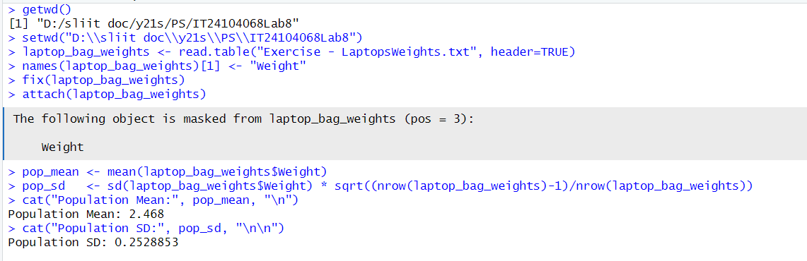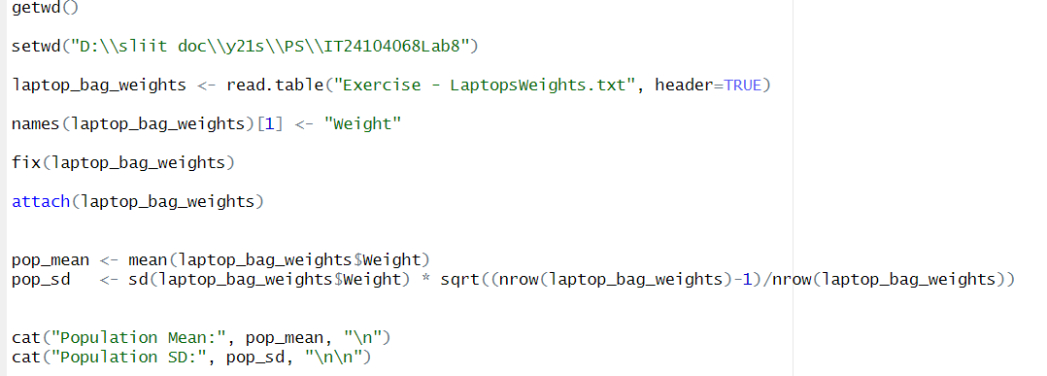

1. **Draw 25 random samples of size 6 (with replacement) and calculate the sample mean and sample standard deviation for each sample.**

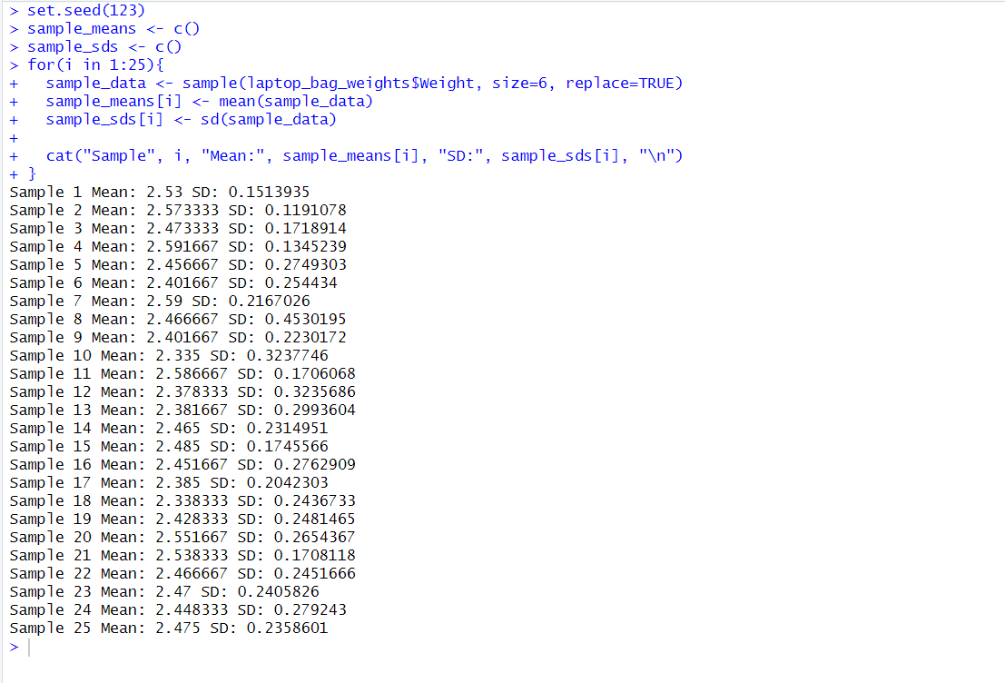

1. **Calculate the mean and standard deviation of the 25 sample means and state the relationship of them with true mean and true standard deviation.**

